WITTE clamps soft plastic injection-molded parts accurately and gently for measuring process

Soft and delicate plastic lids for detergent bottles must be measured during their manufacturing process.

Experience shows that repeatable clamping of these flexible plastic parts is not easy. All kinds of clamping force can act on the components causing them to bend and thus jeopardize the actual measuring process. Any kind of selective clamping pressure, which would ultimately lead to deformation of these sensitive thin-walled injection molded parts, must be avoided.

Therefore a clamping concept is required by which the least possible pressure on workpieces is exerted. All mechanical clamping methods are subject to the risk of deformation, therefore using vacuum was the optimal choice.

The reproducibility of clamping force while maintaining three-dimensional part geometry is very important and during the design phase this was given the highest attention.

A combination of suction cups, vacuum areas, stops and a positioning aid enable simultaneous clamping of 12 workpieces. Workpiece deformation is excluded.

Loading of components is done by hand and for the actual measuring process the complete outer contours of the parts are accessible.

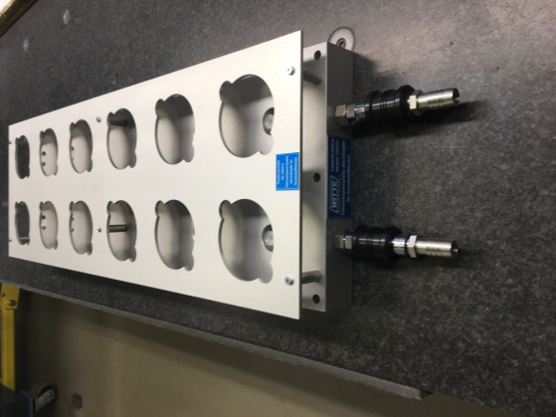

Picture: Vacuum clamping device with positioning mask. (removed after the clamping process for the measuring process).